

American International University-Bangladesh (AIUB)  
**Department of Computer Science  
Faculty of Science &Technology (FST)  
Summer 22 23**

**<Online Old and Children Service>**

Software Requirement Engineering

Sec: **E**

Project submitted

By

*Farib Mojahir Jonak (20-42312-1)*

*MD. Fahim Chowdhury (20-42338-1)*

*MD. Imran Hossen (20-43564-1)*

1. **PROBLEM DOMAIN**
   * **Background to the Problem**

It has been harder for families to care for their elderly members as a result of the fast urbanization and increase in nuclear households in South Asian nations. As a result, elderly individuals are looking for care in old homes managed by non-governmental organizations so they can receive financial and emotional support. The same is true for the numerous orphaned or abandoned children who need a family, a home, and security. Unfortunately, the idea of adoption is still not commonly accepted in many areas of society because of societal conventions. As a result, many couples who are interested in adopting a child find it difficult to get the right advice and assistance.

* + **Solution to the Problem**

The Online Orphan and Homeless Children System has been created to provide a platform that links orphaned and homeless children with potential adoptive parents or guardians in response to these difficulties. By offering information and help to those who are interested in adopting a child, the system also seeks to streamline the adoption procedure. The system also addresses the problem of aged care by giving seniors a platform to connect with volunteers and caregivers who can offer them support and care. The system is designed to ensure the privacy and security of user data and personal information, providing a safe and secure environment for vulnerable populations.

1. **SOLUTION DESCRIPTION**
   * **System Features**

The project focuses on helpless old people and orphaned children. To fulfill its goal properly there will be three interfaces. One for the users who are willing to donate, adopt and help; another for the employees who will connect the people of both sides and an admin interface. Each user of this system will provide a user ID and password, in addition their profile will be made the system which will be monetarized and accessible to the admin.

1. **Adoption and Child Care Information**

* Rescuers shall be shown the details about the baby that needs to be rescued.
* Users shall receive a confirmation notification after placing an order.
* Users shall contact to office if they need adoption.
* Delivery shall deliver the product to the right address
* Rescuers' information shall be collected from the server.

1. **Schedule List and Manage the Data**

* The doctor shall be able to receive work tasks to the database.
* Requested appointment by customer shall be able to send or adding info to the Doctor.
* Doctor shall be able to dis/approve adding/crossing off work from the database.
* Toy service and food service shall be able to receive notice about their order.
* All offline and online actions shall be monitored by the software’s logging feature, in order.

1. **Rescuers and Rescuing Information**

* This system shall have a User Interface to collect, edit and print children’s data.
* User Interface shall have data fields for the following children information like first Name, last Name, other Name, age, gender, dob, phone, street Address, city.
* User Interface shall have a search feature which shall allow children information. Like search by last name or first name.
* User Interface shall have an Edit option to change patient information.
  + **Non-Functional/Quality Requirements**
* The system should be accessible to users with different accessibility needs.
* The system should comply with relevant laws and regulations regarding data privacy and security.
* The system should be scalable to accommodate a growing number of users and transactions.
* The system should provide an intuitive and user-friendly interface for caregivers, elderly people, and children.
* The system should be available at all times with minimal downtime for maintenance or upgrades.
* The system should be compatible with various devices and operating systems.
* The system should consume minimal resources while providing optimal performance and user experience

The non-functional requirements of an online taking care service for children and elderly people include performance, reliability, security, scalability, usability, accessibility, compatibility, interoperability, maintainability, performance efficiency, and data privacy. These requirements ensure that the system provides a secure, reliable, and efficient platform for caregivers, elderly people, and children, while also ensuring that their data is protected and their privacy is respected.

* + **UML Diagrams**
* **Activity Diagram**

An online software for taking care service of children and people can donate for poor people, children, and aged people. People can make appointments for the treatment; they can also get diverse types of service such as adoption and donation. Each customer needs an account. A new customer can request to register an account, he is asked to give email, name, and password. He must fill in the information to complete the registration. Then he will receive a verification mail from the system. If the customer does not verify the link his request will fail. If the link is verified, the customer’s registration will be complete. Then, the customer needs to log in their account, which is verified by the system. If the entered password is incorrect, the system requests for the password and the customer enters password again. The verification repeated 3 times for an incorrect password. If password is incorrect even in 4 times, the account will be blocked for one hour. If the entered password is correct, the customer gets access. After login, a customer can see the option for the service. If the customer places a request to the system for Adoption, he can see the details of adoption and check the details of profile. Customer chooses a child for adoption. The system scans the information and if customer preference is available, it notes them and confirms the request while otherwise cancels it. If the customer places a request for donation or adoption, he can see the details of the organization. He selects the organization for donating the payment option, enter the credit card number, number, and pay the number of amount that he wants to donate. If the customer places a request for doctor's appointment, he can see the information about the doctor. Customers choose the doctor and check the time schedule for taking the appointment then send a request for an appointment. System scans the information and if customer preference is available, system notes them and confirms the request then sends an invoice to the user otherwise cancels the request and sends the new time schedule at the same time.

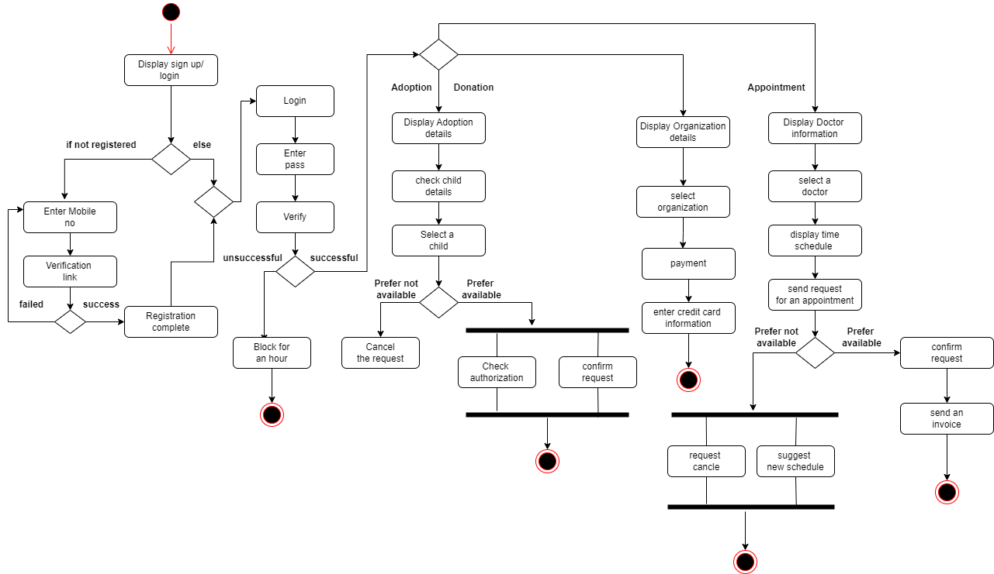

* **Use Case Diagram**

An online software for taking care service of children and people can donate for poor people, children, and aged people. People can make appointments for the treatment; they can also get several types of service such as adoption and donation. Adoptive parents and users must register in this system. All the information will be saved into the database and verified by the system administrator.

Adoptive parent requests for Adoption and child selection after logging in to the account. They can check the personality and medical condition of the selected child. After sending the request for adoption the information system checks the preference availability and authorized by organization manager. Then the system sends a notification to confirm the booking. Users can donate to the aged and poor children. They can select the organization. Users can make an appointment for treatment. System administrator checks the preference for the appointment and sends the confirmation to the user.

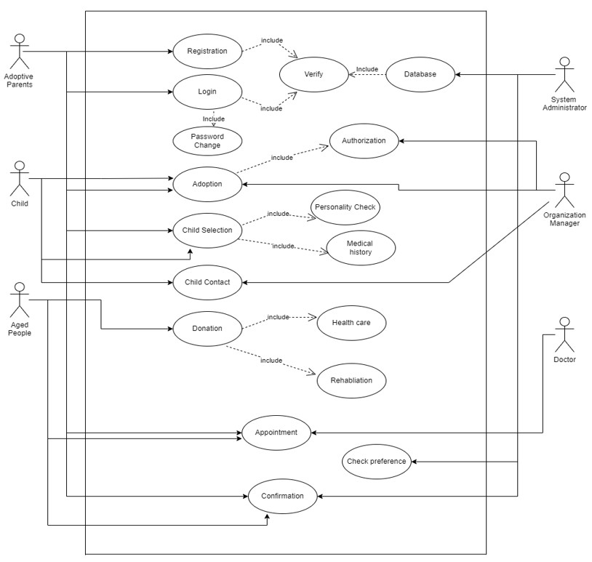

* **ER Diagram**

An online software for taking care service of children and people can donate for poor people, children, and aged people. People can take appointments for the treatment; they can also get several types of service such as adoption and donation. In this system database, we might have entities for Register, Login, Child, Adoptive parents, aged people, doctor, organization, services. Adoptive parents' entity can have attributes like name, job, income, address, email, phone no. They might have relationships with child, doctor, adoption. Doctors' entity can have attributes like name, doc id, phone no, email. They might have relationships with schedule and services. Adoptive parents provide login, register and adoption details. Adoptive parents can see the child's details. Child details can have attributes like dob, child id, name, gender, height, weight. Adoptive parents can request for child adoption. For this the system needs a request id, child id and parent id to track the parents. Users can donate to several types of organization. Organization entity can have attributes like name, email, phone no, address. They might have relationships with adoptive parents and aged people.

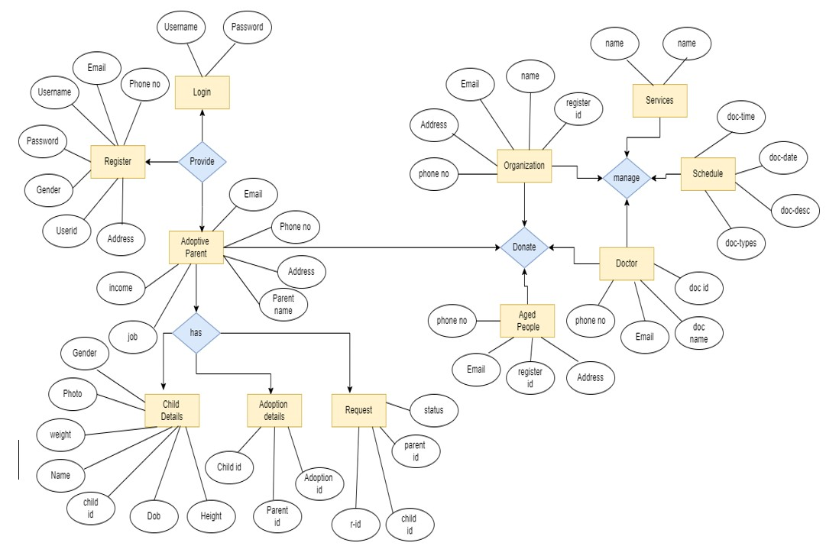

* **Class Diagram**

An online software for taking care service of children and people can donate for poor people, children, and aged people. People can take appointments for the treatment; they can also get several types of service such as adoption and donation. In this system database, we might have entities for Register, Login, Child, Adoptive parents, aged people, doctor, organization, services. Adoptive parents' entity can have attributes like name, job, income, address, email, phone no. They might have relationships with child, doctor, adoption. Doctors' entity can have attributes like name, doc id, phone no, email. They might have relationships with schedule and services. Adoptive parents provide login, register and adoption details. Adoptive parents can see the child's details. Child details can have attributes like dob, child id, name, gender, height, weight. Adoptive parents can request for child adoption. For this the system needs a request id, child id and parent id to track the parents. Users can donate to several types of organization. Organization entity can have attributes like name, email, phone no, address. They might have relationships with adoptive parents and aged people.

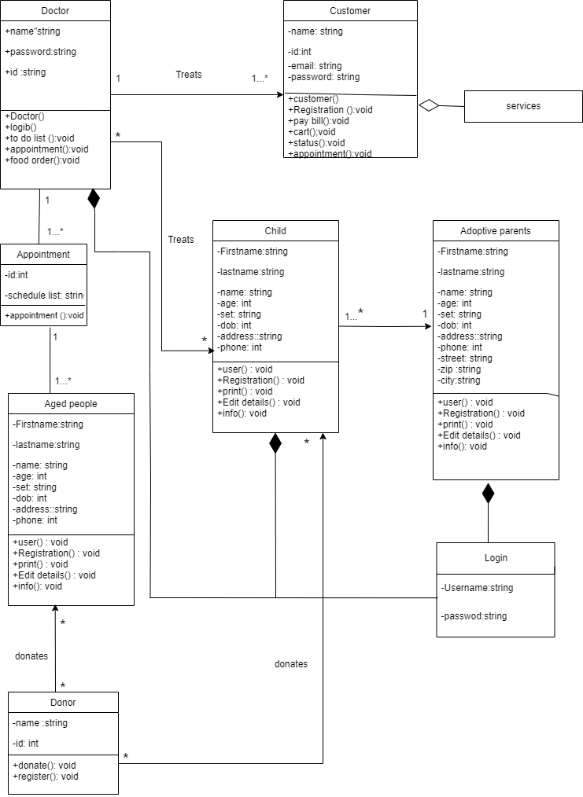

1. **Social Impact**

The "Online Old and Children Service System" is designed to address critical needs within society by focusing on providing financial aid, mental support to the elderly, and facilitating the adoption of orphaned children. The project has the potential to bring about substantial positive changes in the community, creating a ripple effect of social benefits.

* **Improved Quality of Life for the Elderly:**

**Financial Aid:** The project offers financial aid to elderly individuals who may be struggling to make ends meet. This support allows them to access essential resources such as medical care, proper nutrition, and comfortable living conditions, leading to an improved overall quality of life.

**Mental Support:**

By connecting elderly individuals with companions and caregivers through the platform, it provides them with emotional support, reducing feelings of isolation and loneliness. This can lead to improved mental health and a greater sense of belonging.

* **Enhanced Well-being for Orphaned Children:**

**Adoption Opportunities:** The platform acts as a bridge between orphaned children and prospective adoptive parents. By facilitating adoption processes, it provides orphaned children with the chance to be part of loving families, offering them stability, care, and opportunities for personal growth.

**Safe and Nurturing Environments:** Through the adoption process, orphaned children gain access to safe and nurturing environments, which can positively impact their emotional, cognitive, and physical development.

* **Strengthened Community Bonds:**

**Fostered Community Engagement:** The project promotes a sense of community by connecting caregivers, adoptive parents, and individuals seeking support for the elderly. This sense of belonging fosters meaningful relationships and encourages mutual support among members.

**Shared Responsibility:** By encouraging people to contribute to the well-being of elderly individuals and orphaned children, the project reinforces the idea of shared responsibility within society. This can lead to a more compassionate and caring community.

* **Reducing Social Inequalities:**

**Equal Access to Support:** The project ensures that both elderly individuals and orphaned children, regardless of their background or circumstances, have equal access to financial aid, emotional support, and adoption opportunities. This helps in reducing inequalities and promoting social justice.

* **Positive Inter-generational Interaction:**

**Inter-generational Learning:** The platform encourages interactions between generations, fostering an environment where knowledge, experiences, and stories are shared between the elderly and children. This promotes understanding, empathy, and mutual learning.

* **Alleviating Social Welfare Strain:**

Relieving Burden on Social Services: By providing financial aid and support to the elderly, the project can alleviate some of the burdens on public social welfare systems. This allows these systems to focus on other areas while ensuring that elderly individuals receive the care they need.

1. **Development Plan with Project Schedule**
   * **Requirements Gathering and Analysis (Week 1-2)**

Gather detailed requirements from stakeholders regarding financial aid application process, emotional support features, and adoption procedures.

Conduct thorough analysis of legal and regulatory requirements for both financial aid and adoption services.

* + **System Design and Architecture (Week 3-4)**

Design the system architecture, including database structure, user interfaces, and communication channels. Define security measures, authentication mechanisms, and data encryption protocols.

* + **Development and Coding (Week 5-10)**

Develop the frontend interfaces for old people applying for aid and adoptive parents searching for children. Build the backend logic for application submission, matching orphaned children with potential parents, and communication features.

* + **Testing and Quality Assurance (Week 11-12)**

Conduct rigorous testing to identify and rectify any functional, security, or usability issues. Ensure compatibility with various devices and browsers.

* + **Deployment and User Training (Week 13-14)**

Deploy the system on a secure server, implementing necessary backup and recovery measures.Provide training sessions for old people, adoptive parents, and support volunteers to effectively use the platform.

* + **Monitoring and Maintenance (Week 15-16 and ongoing)**

Monitor system performance, user feedback, and adoption success rates.

Implement regular updates, security patches, and continuous improvements based on user feedback.

1. **Marketing Plan**

* **Short-Term Plan (3-6 month)**

**Brand Awareness:**

Launch social media campaigns on platforms like Facebook, Instagram, and Twitter to introduce the platform. Use engaging posts, videos, and infographics highlighting the benefits of the service.

**Partnerships:**

Collaborate with local retirement homes, community centers, and pediatric clinics to promote the service. Offer special incentives for referrals.

**Promotions:**

Provide limited-time discounts for the first users to encourage early adoption.

**Local Events:**

Attend local fairs, expos, and workshops to showcase the platform's features and engage directly with potential users.

* **Long-Term Plan (6-12 month)**

**User Reviews and Testimonials:**

Highlight positive user experiences through case studies, testimonials, and video interviews, building credibility and trust.

**Content Marketing:**

Start a blog on the platform's website with informative articles related to elderly and childcare issues. This will position the platform as an authoritative source in the industry.

**SEO Strategy:**

Optimize the website for relevant keywords to improve organic search rankings, driving traffic and user acquisition.

**Referral Program:**

Implement a referral program where existing users can earn rewards for bringing in new clients or caregivers.

**Community Engagement:**

Organize workshops, webinars, or seminars on topics related to elderly care and childcare, fostering a sense of community around the platform.

* **Continuous Plan (ongoing)**

**Quality Assurance:**

Continuously monitor and improve the quality of service through feedback loops and regular user surveys.

**Customer Support:**

Offer responsive and empathetic customer support to address any concerns or issues promptly.

**Social Media Presence:**

Maintain an active presence on social media platforms, sharing success stories, updates, and relevant news.

**Data Analytics:**

Utilize data analytics to track user behavior, preferences, and trends. Use these insights to refine marketing strategies and improve user experience.

**Partnership Expansion:**

Forge partnerships with local businesses and organizations to expand the reach and impact of the platform.

**Adaptation:**

Stay updated with industry trends and adapt the platform's features and services accordingly to meet changing user needs.

1. **Cost and Profit Analysis**

* **Cost Analysis**

**Development Costs:**

Website and App Development: $40,000

Platform Features and Functionality: $15,000

User Interface and Experience Design: $12,000

Backend Infrastructure Setup: $8,000

Testing and Quality Assurance: $5,000

Total Development Costs: $80,000

**Marketing Costs:**

Social Media Advertising: $10,000

Content Creation and Marketing: $8,000

Events and Promotions: $5,000

Partnerships and Collaborations: $4,000

SEO and Online Presence: $3,000

Customer Support and Quality Assurance: $2,000

Total Marketing Costs: $32,000

**Operational Costs (Monthly):**

Server Hosting and Maintenance: $500

Customer Support Personnel: $3,000

Marketing Campaigns and Materials: $1,500

Miscellaneous Expenses: $1,000

Total Monthly Operational Costs: $6,000

* **Profit Analysis**

**Projected Revenue Streams (Monthly):**

User Subscriptions (Elderly Care): 200 subscriptions at $30/month = $6,000

User Subscriptions (Childcare): 300 subscriptions at $25/month = $7,500

Commission from Caregivers: 50 caregivers at $50/month = $2,500

Total Projected Monthly Revenue: $16,000

**Gross Profit Calculation (Monthly):**

Total Revenue: $16,000

Total Monthly Operational Costs: $6,000

Gross Profit: $16,000 - $6,000 = $10,000

**Annual Gross Profit:**

Gross Profit (Monthly): $10,000

Gross Profit (Yearly): $10,000 * 12 months = $120,000

**Net Profit Calculation (Annual):**

Annual Gross Profit: $120,000

Development Costs: $80,000

Marketing Costs: $32,000

Annual Operational Costs: $6,000 * 12 months = $72,000

Total Costs: $80,000 + $32,000 + $72,000 = $184,000

Net Profit: $120,000 - $184,000 = -$64,000

**Break-Even Point Calculation:**

Break-Even Revenue: Total Costs / Gross Profit Margin = $184,000 / ($16,000 - $6,000) = $18,400

Break-Even Subscriptions (Elderly Care): $18,400 / $30 = 613 subscriptions

Break-Even Subscriptions (Childcare): $18,400 / $25 = 736 subscriptions

Investors are encouraged to consider the potential profitability of the Online Old and Children Service System. While the projected revenue streams show promising growth, the initial development and marketing costs result in a net loss in the first year. However, the break-even analysis indicates the number of subscriptions needed to cover costs, demonstrating the path towards profitability as the user base grows. As the platform gains traction and user engagement increases, the potential for long-term profitability becomes more evident.

1. **Reference**

* <https://imaginovation.net/blog/website-development-cost-complete-guide/>
* <https://www.lucidchart.com/blog/cost-benefit-analysis>
* <https://www.freshbooks.com/hub/accounting/calculate-break-even-point>
* <https://www.wix.com/blog/promote-website-free>